Accessibility in General Election 2020

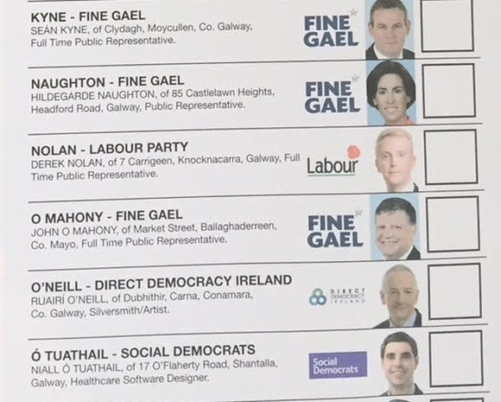  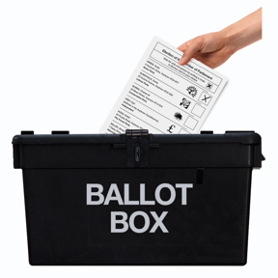  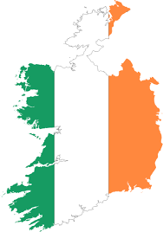 | This is a survey about voting in the General Election 2020.
 | Maria Ní Fhlatharta and Vivian Rath are disabled people and they want to hear if other disabled people were able to vote in the election or if they found it hard to vote.
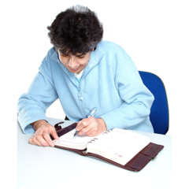 | Maria and Vivian will write about what they found out in this survey.
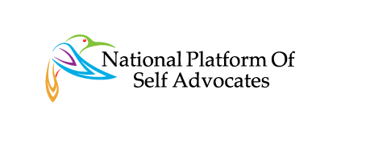 | They will share this information with Disabled People’s Organisations and activists so they can campaign to make things better.
 | If you did not try to vote in the General Election you should not fill in this form.
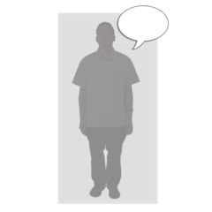 | You don’t have to give us your name or any details about you.

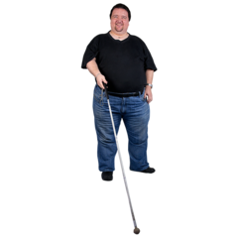  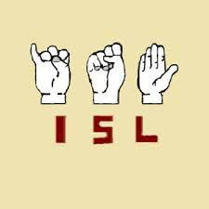  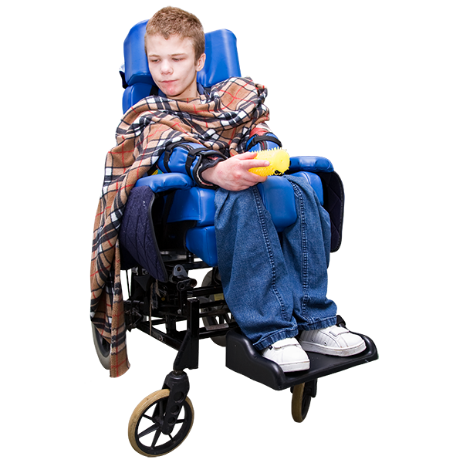  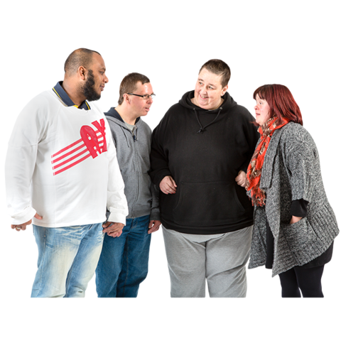  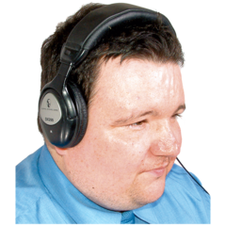 | Do you have a disability? | Yes | No
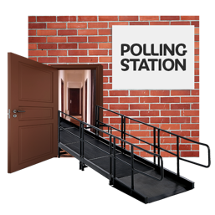 | Did you find it hard to vote in the election? | Yes | No
Please tell us why it was hard for you to vote
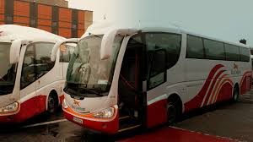 | It was hard for me to get to the polling station (where I should vote) | Yes | No
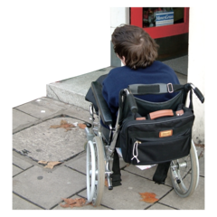 | I was not able to get inside the building where I should  vote | Yes | No
 | I was not sure how to vote | Yes | No

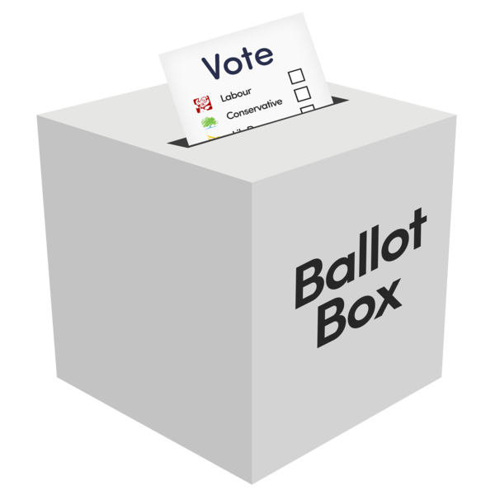 | I could not put the ballot paper in the box | Yes | No
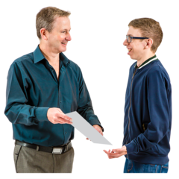 | I didn't have PA or other support person to help me | Yes | No
 | There was not enough accessible information about the election | Yes | No
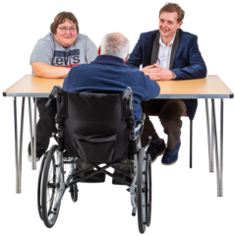 | The staff at the polling station didn’t know about disability | Yes | No
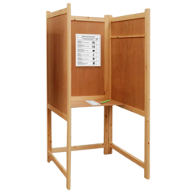 | The polling booth was not accessible | Yes | No

 | Do you know how to complain about a problem with voting? | Yes | No

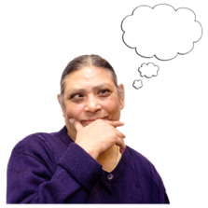 | Is there something else that made voting difficult for you that we have not thought of? Please tell us about it.

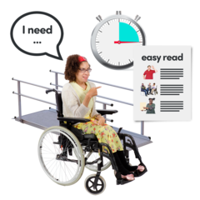 | What would have made voting easier for you?

Postal Voting
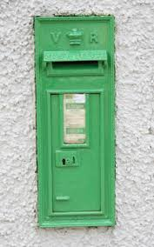 | Did you send your vote by post instead of going to a polling station? | Yes | No

If you did send your vote by post what was it like?

If you didn’t vote, why not?

 | If you have questions or need help with the survey you should contact
 | Maria at marianifhlatharta@gmail.com or 091 494272
Or

Vivian on Twitter @RathVivian

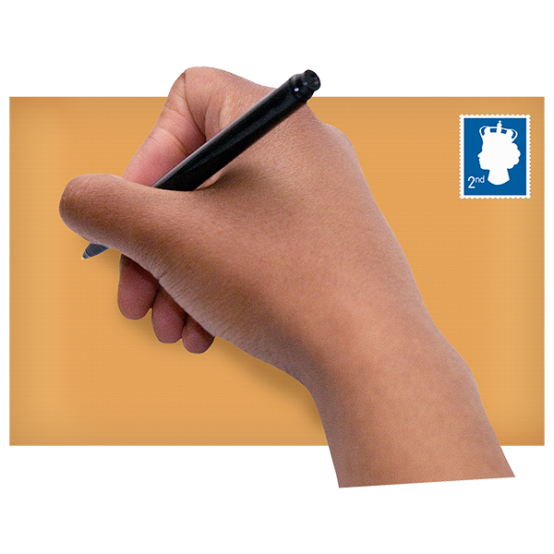 | Please send your finished survey by the 23rd of February.  Post it to or Email it.  Maria Ni Fhlatharta  G029  ILAS Building  NUI Galway

